12. Scenario: You are working on a data analysis project that involves analyzing the monthly

temperature and rainfall data for a city. You have a dataset containing the monthly temperature and

rainfall values for each month of a year. Your task is to develop a Python program that generates

line plots and scatter plots to visualize the temperature and rainfall data.

Question:

1. Develop a Python program to create a line plot of the monthly temperature data.

2: Develop a Python program to create a scatter plot of the monthly rainfall data.

**Code:**

**import** pandas **as** pd

**import** matplotlib.pyplot **as** plt

data **=** pd.read_csv(r"C:\Users\vara prasad\Downloads\monthly_temp_rainfall.csv")

*# Line Plot: Monthly Temperature*

plt.figure(figsize**=**(8,4))

plt.plot(data['Month'], data['Temperature_C'], marker**=**'o', color**=**'red', linestyle**=**'-')

plt.title('Monthly Temperature')

plt.xlabel('Month')

plt.ylabel('Temperature (°C)')

plt.grid(**True**)

plt.xticks(rotation**=**45)

plt.tight_layout()

plt.show()

*# Scatter Plot: Monthly Rainfall*

plt.figure(figsize**=**(8, 4))

plt.scatter(data['Month'], data['Rainfall_mm'], color**=**'blue')

plt.title('Monthly Rainfall')

plt.xlabel('Month')

plt.ylabel('Rainfall (mm)')

plt.grid(**True**)

plt.xticks(rotation**=**45)

plt.tight_layout()

plt.show()

output:

1.line plot

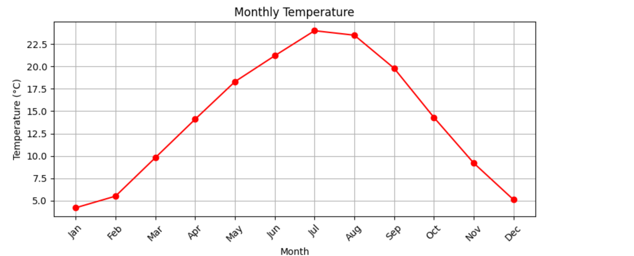

2.scatter plot

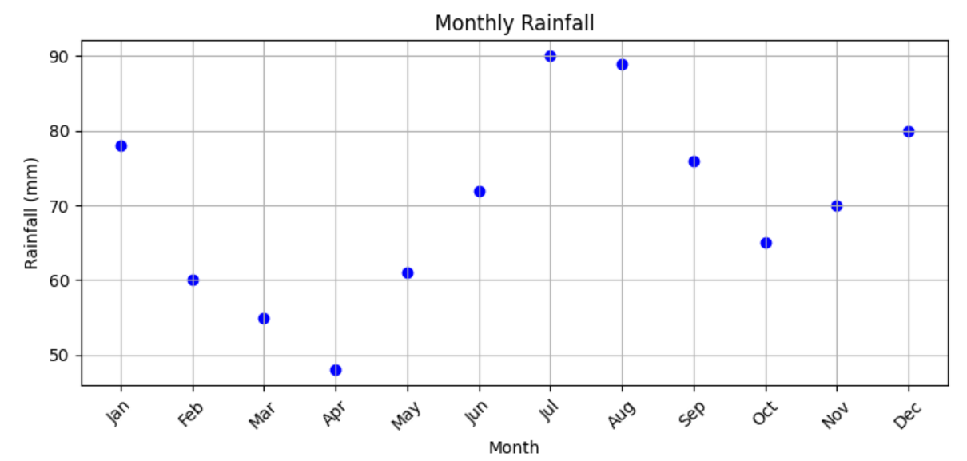

**Dataset:**

|  |  |  |
| --- | --- | --- |
| Month | Temperature_C | Rainfall_mm |
| Jan | 4.2 | 78 |
| Feb | 5.5 | 60 |
| Mar | 9.8 | 55 |
| Apr | 14.1 | 48 |
| May | 18.3 | 61 |
| Jun | 21.2 | 72 |
| Jul | 24 | 90 |
| Aug | 23.5 | 89 |
| Sep | 19.8 | 76 |
| Oct | 14.3 | 65 |
| Nov | 9.2 | 70 |
| Dec | 5.1 | 80 |
|  |  |  |